### Alarm Mimic

The *alarm mimic* is the central place where all relevant alarms are shown in clear and unambiguous language and coloring. The smaller *Alarm area* in the taskbar will always be available and visible. Here, each alarm will be shown immediately. When you click the area, the larger Alarm mimic is shown (see Figure 1‑25).

*The Alarm mimic will always be on top of all the other windows, so if you want to look at other mimics, you will need to close the alarm mimic first.*

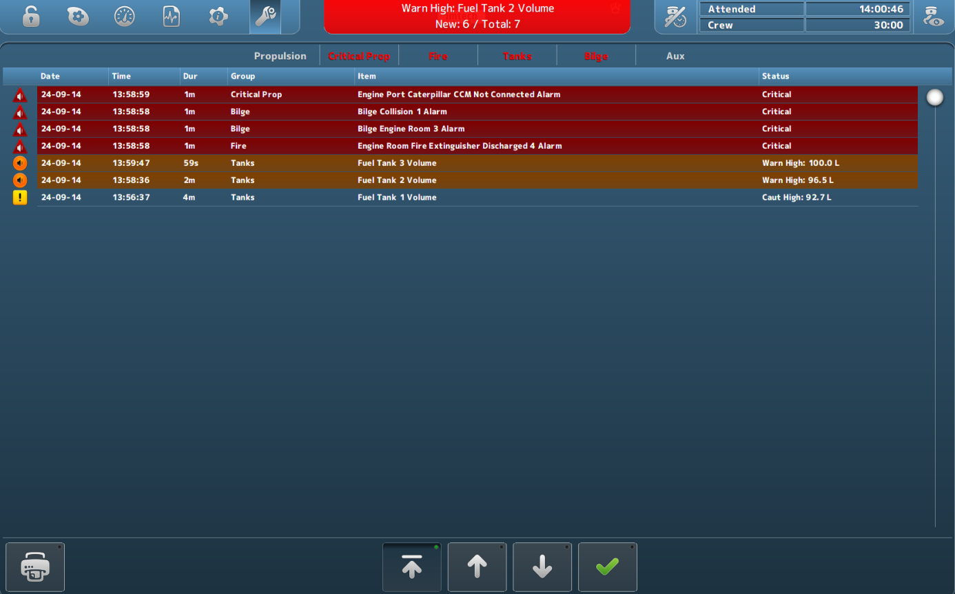

Figure 1‑25: Alarm mimic

Depending on which rights your station has, more or less buttons and/or alarm-information are shown.

The order will always be as follows:

* Critical alarms
* Warnings
* Cautions
* Time of appearance

So the latest *critical alarm* will always be on top. The latest *warning* will always be on top, after all *critical alarms.* Similarly, the latest *caution* will always be on top after all *critical alarms* and/or *warnings*.

#### Alarm icons

The alarm icons have distinctive colors and symbols, so you can see exactly what is going on with each alarm. A brief explanation of each icon is shown in the following table.

|  |  |
| --- | --- |
| **Icon** | **Explanation** |
|  | Critical alarm: Unacknowledged |
|  | Critical alarm: Silenced |
|  | Critical alarm: Acknowledge not allowed |
|  | Critical alarm: Acknowledged |
|  | Critical alarm: Rectified |
|  | Critical alarm: Transferred |
|  | Warning: Unacknowledged |
|  | Warning: Silenced |
|  | Warning: Acknowledge not allowed |
|  | Warning: Acknowledged |
|  | Warning: Rectified |
|  | Warning: Transferred |
|  | Caution: Unacknowledged |
|  | Caution: Silenced |
|  | Caution: Acknowledge not allowed |
|  | Caution: Acknowledged |
|  | Caution: Rectified |
|  | Caution: Transferred |

Table 5: Alarm Icons

The bottom of the alarm mimic houses buttons for printing and scrolling.



Figure 1‑26: Print button

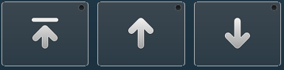

Figure 1‑27: Up- down buttons

Upon clicking the *Print* button, you can print the alarm list (if a printer is available). With the *Up/Down* buttons you can scroll up, down or jump to the top of the list.